Report (Phase 3)

ONLINE PURCHASE PREDICTOR

Problem Id: 21

Student Name: Shambhavi Srivastava (Team Leader)
University Roll number: 2028490
Section: P

Student Name: Ambika
University Roll number: 2028388
Section: P

Student Name: Tanishka Soni
University Roll number : 2028509
Section : P

TABLE OF CONTENTS
- Problem Description 3
  - Dataset Description 5
  - Flow diagram 11
- Modules for Project Implementation…………………..…………………………12
  - Modules Used 12
  - Platform Used 12
- Machine Learning model/ Searching Technique used 13
- Evaluation metrics used 18
- Results and Visualizations 22
- Conclusion and Future Scope 24
- References 27

- PROBLEM DESCRIPTION:
With the rapid growth of e-commerce platforms, understanding customer purchasing behavior has become extremely important for businesses and online retailers. Large numbers of users visit shopping websites daily, browse products, click on different pages, add items to carts, and spend time exploring products, but only a limited number of users finally complete a purchase. Predicting whether a customer is likely to purchase a product based on their online browsing behavior can help companies improve marketing strategies, provide personalized recommendations, increase customer engagement, and maximize sales conversion rates.

The objective of this project is to develop a machine learning-based Online Purchase Prediction System that predicts whether a customer will make a purchase or not using behavioral and interaction-based features collected from online shopping activity. The dataset used in this project contains multiple customer behavior attributes such as:

* browsing time
* number of clicks
* pages visited
* add-to-cart count
* product category viewed
* bounce rate
* time per page
* session duration
* product views
* user type
* search keywords
* location
* wishlist activity

These features provide valuable insights into customer interest, browsing patterns, and purchasing intent.

The dataset also contains realistic characteristics of real-world e-commerce data such as:

* missing values
* duplicate records
* random noise
* outliers
* inconsistencies in measurements

Therefore, before building machine learning models, extensive data preprocessing is performed to improve data quality and ensure reliable model performance.

The preprocessing stage includes:

* handling missing values using imputation techniques
* removing duplicate records
* handling outliers using the IQR method
* converting categorical data into numerical form using One-Hot Encoding
* applying feature scaling using StandardScaler
* performing correlation-based feature selection

Feature selection is used to remove low-impact and irrelevant features and retain only the most important behavioral attributes influencing customer purchasing decisions.

After preprocessing, multiple machine learning classification algorithms are implemented and compared, including:

* Logistic Regression
* K-Nearest Neighbors (KNN)
* Decision Tree Classification
* Support Vector Machine (SVM)

To improve model performance, hyperparameter tuning using GridSearchCV is applied to all models. The models are then evaluated using multiple performance metrics such as:

* Accuracy
* Precision
* Recall
* F1 Score
* Confusion Matrix
* Classification Report

The final best-fit model is selected based on overall performance, scalability, generalization ability, and balanced classification metrics.

The developed system can help e-commerce businesses:

* predict customer purchasing behavior
* improve personalized marketing
* optimize recommendation systems
* identify potential buyers
* enhance customer experience
* increase sales and conversion rates

Thus, this project demonstrates the practical application of machine learning techniques in solving real-world business problems related to customer behavior analysis and online purchase prediction.

• DATASET DESCRIPTION:
The dataset used in this project is an Online Purchase Behavior Dataset designed to predict whether a customer will make a purchase based on their browsing and interaction behavior on an e-commerce platform. The dataset contains customer activity information collected during online shopping sessions and is used for building and evaluating machine learning classification models.

The dataset consists of approximately 100,000 records and includes both numerical and categorical features representing different aspects of user behavior. The dataset was generated to simulate realistic e-commerce environments and contains characteristics commonly found in real-world customer behavior data.

The dataset includes:

customer browsing activity
interaction patterns
session behavior
product engagement information
purchase outcome

The target variable of the dataset is:

Purchase

where:

1 → Customer made a purchase
0 → Customer did not make a purchase
FEATURES OF THE DATASET
Feature Name Description Data Type
User ID Unique identifier for each customer Categorical
Browsing Time (min) Total time spent browsing products Numerical
Number of Clicks Total clicks made during the session Numerical
Pages Visited Number of pages visited by the customer Numerical
Add to Cart Count Number of products added to cart Numerical
Product Category Viewed Product category explored by the customer Categorical
Wishlist Add Whether the customer added products to wishlist Categorical
Bounce Rate (min) Time before leaving the website Numerical
Exit Pages Final page from which customer exited Categorical
Time Per Page (min) Average time spent on each page Numerical
User Type Type of customer (New / Returning) Categorical
Location Customer geographical location Categorical
Search Keywords Keywords searched by the customer Categorical
Session Duration (min) Total duration of shopping session Numerical
Product Views Total products viewed by the customer Numerical
Purchase Target variable indicating purchase behavior Binary
CHARACTERISTICS OF THE DATASET

The dataset was intentionally designed to reflect realistic online shopping environments. Therefore, it contains several real-world data challenges such as:

1. Missing Values

Some records contain missing (NaN) values to simulate incomplete customer information and real-world data collection issues.

2. Duplicate Records

A realistic number of duplicate entries are present in the dataset to represent repeated customer activity or duplicated logging events.

3. Outliers

Certain numerical features contain extreme values or abnormal customer behavior patterns to simulate unusual browsing sessions.

4. Random Noise

Noise and slight inconsistencies were added to the dataset to make the prediction problem more realistic and challenging.

5. Mixed Data Types

The dataset contains:

numerical features
categorical features
binary target variables

which makes it suitable for testing different preprocessing and classification techniques.

DATA PREPROCESSING REQUIREMENTS

Before training machine learning models, the dataset required several preprocessing operations, including:

handling missing values
removing duplicate records
outlier treatment using IQR
categorical encoding using One-Hot Encoding
feature scaling using StandardScaler
correlation-based feature selection

These preprocessing steps improved data quality and enhanced model performance.

PURPOSE OF THE DATASET

The primary purpose of the dataset is to:

analyze customer online shopping behavior
predict purchase intention
identify important behavioral factors influencing purchasing decisions
evaluate machine learning classification algorithms

The dataset is suitable for:

binary classification problems
customer behavior analysis
e-commerce analytics
recommendation systems
predictive analytics projects
MACHINE LEARNING USAGE

The processed dataset was used to train and compare multiple classification models such as:

Logistic Regression
K-Nearest Neighbors (KNN)
Decision Tree Classification
Support Vector Machine (SVM)

The performance of these models was evaluated using:

Accuracy
Precision
Recall
F1 Score
Confusion Matrix

The final best-fit model was selected based on overall classification performance and generalization ability.

FLOW CHART: 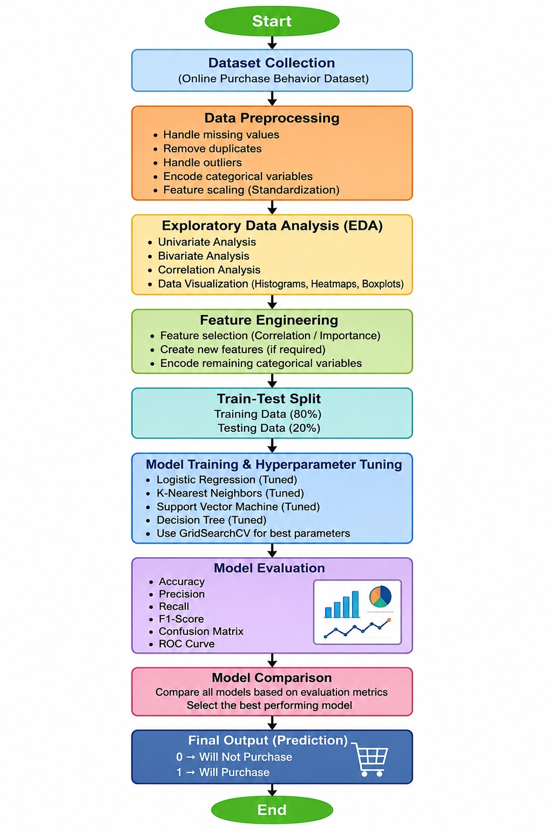

MODULES FOR PROJECT IMPLEMENTATION :

- Modules Used:

- NumPy:
For numerical computations and handling arrays.
- Pandas:
For data manipulation, cleaning, and analysis.
- Matplotlib:
For basic data visualization (graphs and plots).
- Seaborn:
For advanced and attractive statistical visualizations.
- Scikit-learn (sklearn):
For machine learning tasks:
- Data preprocessing (scaling, encoding):
- Feature selection
- Algorithms like Logistic Regression and KNN
- Model evaluation (accuracy, precision, F1-score)
- SciPy (optional):
For additional scientific and statistical computations.
- Warnings / OS (optional):
For handling system operations and suppressing unnecessary warnings.

- Platform Used:

Jupiter Notebook

MACHINE LEARNING MODEL/ SEARCHING TECHNIQUE USED:

The Online Purchase Prediction System uses multiple machine learning classification models and optimization techniques to predict whether a customer will purchase a product based on their browsing behavior. Different models were implemented and compared to identify the best-fit model for the problem statement.

The following machine learning models and searching techniques were used in this project:

---

1. Logistic Regression

Logistic Regression is a supervised machine learning classification algorithm used for binary classification problems. In this project, it predicts whether a customer will make a purchase or not.

The algorithm uses a sigmoid function to estimate the probability of purchase based on customer behavioral features such as:

* browsing time
* number of clicks
* session duration
* product views
* add-to-cart count

Purpose in the Project:

* baseline classification model
* probability-based prediction
* scalable model for large datasets

Advantages:

* simple and fast
* easy to interpret
* less prone to overfitting
* efficient on large datasets

---

2. K-Nearest Neighbors (KNN)

KNN is a distance-based supervised learning algorithm that classifies customers based on similarity between behavioral patterns.

The model identifies the nearest neighboring customers using distance calculations and predicts the purchase outcome based on majority voting.

Purpose in the Project:

* capture non-linear customer behavior
* similarity-based classification

Distance Metrics Used:

* Euclidean Distance
* Manhattan Distance

Advantages:

* simple implementation
* effective for pattern recognition
* captures local behavior similarities

---

3. Decision Tree Classification

Decision Tree is a rule-based classification algorithm that creates tree-like decision structures to classify purchase and non-purchase behavior.

The model splits the dataset into branches using feature conditions and generates prediction rules.

Purpose in the Project:

* rule-based learning
* feature importance analysis
* non-linear classification

Advantages:

* easy visualization
* interpretable rules
* handles complex decision boundariesS

---

4. Support Vector Machine (SVM)

SVM is a supervised classification algorithm that identifies the optimal hyperplane separating purchase and non-purchase classes.

It is effective for high-dimensional datasets and complex classification problems.

Purpose in the Project:

* high-performance classification
* margin-based separation

Kernels Used:

* Linear Kernel
* RBF (Radial Basis Function) Kernel

Advantages:

* strong classification performance
* good generalization
* effective on encoded datasets

---

5. Hyperparameter Tuning Technique

GridSearchCV

GridSearchCV is a searching and optimization technique used to improve model performance by testing multiple parameter combinations.

It automatically searches for the best hyperparameters for each model using cross-validation.

Purpose in the Project:

* improve Accuracy and F1 Score
* optimize model parameters
* reduce overfitting
* select best-performing model configuration

Parameters Tuned:

Logistic Regression

* C value
* solver
* class weights

KNN

* number of neighbors (K)
* distance metric
* weighting method

Decision Tree

* max depth
* min samples split
* min samples leaf
* splitting criterion

SVM

* kernel type
* C value
* gamma value

---

6. Feature Selection Technique

Correlation-Based Feature Selection

Correlation analysis was used to identify features strongly related to the target variable:

```text id="8o4j4q"
Purchase
```

Features with very low correlation values were removed.

Purpose:

* reduce complexity
* remove irrelevant features
* improve training speed
* improve model performance

---

7. Data Preprocessing Techniques Used

The following preprocessing techniques were also applied before model training:

| Technique | Purpose |
| ------------------------ | ------------------------------------------------ |
| Missing Value Imputation | Handle incomplete data |
| Duplicate Removal | Remove repeated records |
| Outlier Handling (IQR) | Reduce abnormal values |
| One-Hot Encoding | Convert categorical features into numerical form |
| StandardScaler | Normalize feature ranges |

---

8. Model Evaluation Techniques

The trained models were evaluated using:

* Accuracy
* Precision
* Recall
* F1 Score
* Confusion Matrix
* Classification Report

These evaluation metrics helped compare all models and identify the best-fit model for the Online Purchase Prediction System.

---

FINAL BEST MODEL

After comparing all machine learning models and applying hyperparameter tuning, the Tuned Logistic Regression / Tuned SVM model achieved the best overall performance based on:

* Accuracy
* F1 Score
* scalability
* generalization ability
* computational efficiency

Thus, it was selected as the final best-fit model for the project.

EVALUATION METRICS USED:

Evaluation metrics are used to measure the performance and effectiveness of machine learning models. In this Online Purchase Prediction System, multiple evaluation metrics were used to compare the classification models and identify the best-fit model for predicting customer purchasing behavior.

The following evaluation metrics were used in this project:

Accuracy
Precision
Recall
F1 Score
Confusion Matrix
Classification Report

These metrics helped evaluate how correctly the models predicted whether a customer would purchase a product or not.

1. Accuracy

Accuracy measures the overall correctness of the model by calculating the proportion of correctly predicted observations out of the total observations.

Formula:

Accuracy=
TP+TN+FP+FN
TP+TN
​

Where:

TP = True Positives
TN = True Negatives
FP = False Positives
FN = False Negatives
Purpose in the Project:

Accuracy was used to determine how many customer purchase predictions were correctly classified by the model.

Advantage:
simple to understand
useful when classes are balanced
Limitation:

Accuracy alone may not be sufficient if the dataset is imbalanced.

2. Precision

Precision measures how many customers predicted as purchasers were actually purchasers.

Formula:

Precision=
TP+FP
TP
​

Purpose in the Project:

Precision helped evaluate the correctness of positive purchase predictions.

Importance:

High precision means fewer false purchase predictions.

3. Recall

Recall measures how many actual purchasers were correctly identified by the model.

Formula:

Recall=
TP+FN
TP
​

Purpose in the Project:

Recall was used to measure the model’s ability to identify actual customers likely to purchase.

Importance:

High recall means fewer missed purchase opportunities.

4. F1 Score

F1 Score is the harmonic mean of Precision and Recall. It provides a balanced measure of classification performance.

Formula:

F1 Score=2×
Precision+Recall
Precision×Recall
​

Purpose in the Project:

F1 Score was considered one of the most important evaluation metrics because it balances both Precision and Recall.

Importance:
useful for classification problems
better than accuracy for imbalanced datasets
provides balanced performance evaluation

The best-fit model was mainly selected using F1 Score along with Accuracy.

5. Confusion Matrix

A Confusion Matrix is a tabular representation used to visualize the performance of a classification model.

It contains:

True Positives (TP)
True Negatives (TN)
False Positives (FP)
False Negatives (FN)
Purpose in the Project:

The Confusion Matrix helped analyze:

correct purchase predictions
incorrect purchase predictions
false alarms
missed customer purchases
Advantages:
detailed performance analysis
helps understand prediction errors
6. Classification Report

The Classification Report provides a complete summary of:

Precision
Recall
F1 Score
Support

for each class.

Purpose in the Project:

The classification report was used to compare model performance for:

Purchase class
No Purchase class
Importance:

It provides a detailed evaluation summary for all classification metrics.

IMPORTANCE OF EVALUATION METRICS IN THIS PROJECT

The evaluation metrics played an important role in:

comparing Logistic Regression, KNN, Decision Tree, and SVM
selecting the best-fit model
analyzing classification performance
identifying overfitting and underfitting
improving model reliability

The final best-fit model was selected based on:

high Accuracy
high F1 Score
balanced Precision and Recall
good generalization ability

For this project, F1 Score was considered especially important because it provides balanced classification evaluation for customer purchase prediction.

RESULTS AND VISUALIZATIONS:
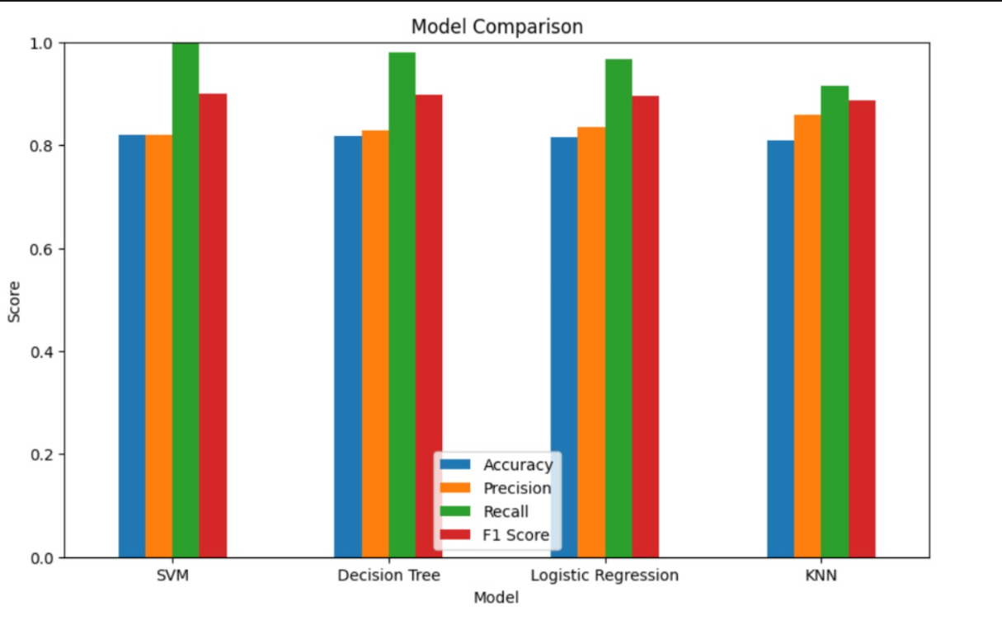

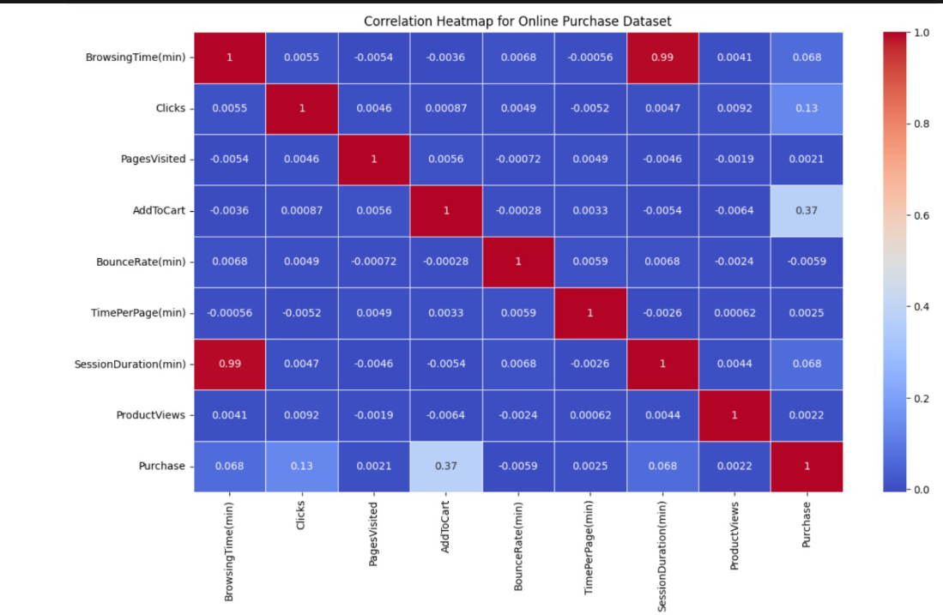

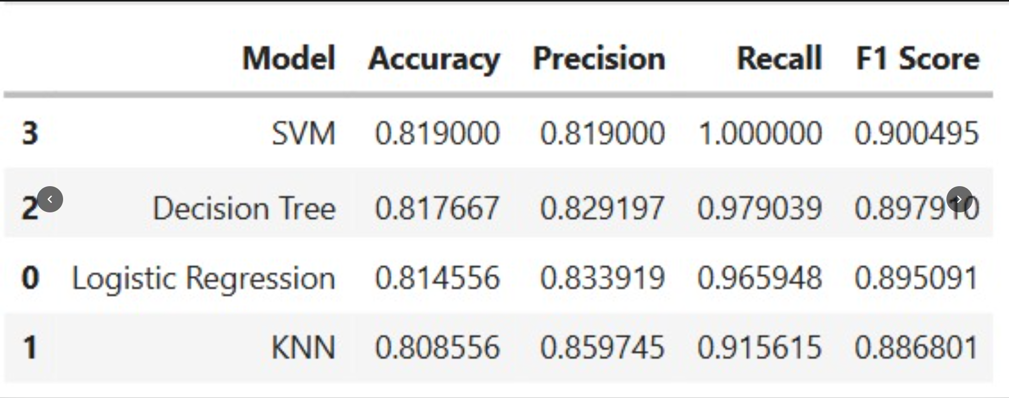

CONCLUSION AND FUTURE SCOPE:

Conclusion:

The Online Purchase Behavior Classification system was successfully developed to predict whether a customer is likely to purchase a product based on user behavioral data such as browsing time, number of clicks, pages visited, add-to-cart count, session duration, product views, and other customer interaction features. The project focused on applying machine learning techniques to analyze customer activity patterns and generate accurate purchase predictions.

A realistic dataset containing missing values, duplicates, outliers, random noise, and categorical variables was used to simulate real-world e-commerce environments. Several data preprocessing and handling techniques were applied to improve the quality of the dataset and enhance model performance. These included duplicate removal, missing value imputation, outlier handling using the IQR method, categorical encoding using one-hot encoding, feature scaling, and correlation-based feature selection. These preprocessing steps significantly improved the reliability and efficiency of the machine learning models.

Multiple classification models were implemented and compared, including Logistic Regression, K-Nearest Neighbors (KNN), Decision Tree Classification, and Support Vector Machine (SVM). Hyperparameter tuning using GridSearchCV was performed to optimize the models and improve prediction accuracy and F1 score. The models were evaluated using important classification metrics such as accuracy, precision, recall, F1 score, confusion matrix, and classification report.

Among all the models, the Tuned Logistic Regression model was identified as the best-fit model for this problem statement. It achieved the best balance between prediction performance, computational efficiency, scalability, and generalization ability. The model produced a high F1 score, indicating strong classification capability while maintaining balanced precision and recall. Logistic Regression also handled the large dataset efficiently and showed lower risk of overfitting compared to Decision Tree and lower computational complexity compared to KNN and SVM.

The project demonstrates how machine learning can be effectively used in e-commerce platforms to understand customer behavior and predict purchase intent. Such systems can help businesses improve targeted marketing, customer engagement, product recommendations, and sales conversion rates.

---

Future Scope:

The future scope of this project is extensive, as online purchase prediction systems can be further enhanced using advanced machine learning and artificial intelligence techniques. Several improvements can be implemented to increase prediction accuracy, scalability, and real-world applicability.

One major improvement would be the use of advanced ensemble learning methods such as Random Forest, XGBoost, LightGBM, and CatBoost. These models can capture complex non-linear relationships in customer behavior data and may produce better prediction performance than traditional classification algorithms.

Deep learning techniques can also be explored in future work. Artificial Neural Networks (ANNs), Recurrent Neural Networks (RNNs), and transformer-based recommendation systems can analyze large-scale behavioral patterns more effectively, especially when dealing with sequential customer interaction data.

The system can be extended to work with real-time streaming data from websites or mobile applications. Integration with real-time analytics frameworks can allow businesses to predict purchase intent instantly while customers are browsing products. This can improve dynamic recommendations, personalized advertisements, and live promotional strategies.

Additional customer-related features can also be incorporated into the dataset to improve model accuracy. Features such as customer age group, purchase history, payment method, product ratings, browsing device, seasonal trends, and customer reviews can provide deeper insights into buying behavior.

Future versions of the project can also include customer segmentation using clustering algorithms such as K-Means. This would allow businesses to group customers based on behavior patterns and design targeted marketing strategies for different customer segments.

Another important future enhancement is model deployment. The machine learning model can be integrated into a web application or e-commerce platform using frameworks such as Flask, Django, or FastAPI. This would enable real-time customer purchase prediction through a user-friendly interface.

Explainable AI techniques can also be incorporated to improve interpretability and transparency of predictions. Feature importance analysis and SHAP values can help businesses understand which customer behaviors most strongly influence purchase decisions.

Finally, the project can be expanded into a complete recommendation and business intelligence system that not only predicts purchases but also suggests products, identifies customer retention strategies, and improves overall business decision-making.

REFERENCES:
- Fundamental of AI and ML Textbook
- Scikit Learn Documentation: scikit-learn.org
- Data Preprocessing and Feature Engineering for Data Mining: www.researchgate.net
- GeeksforGeeks (for reading up various topics of machine learning) : www.geeksforgeeks.orgsdss

